LIFESAVING SOCIETY
LIFESAVING SPORT COMPETITION HANDBOOK

Canadian Pool Lifesaving Championships
YEAR

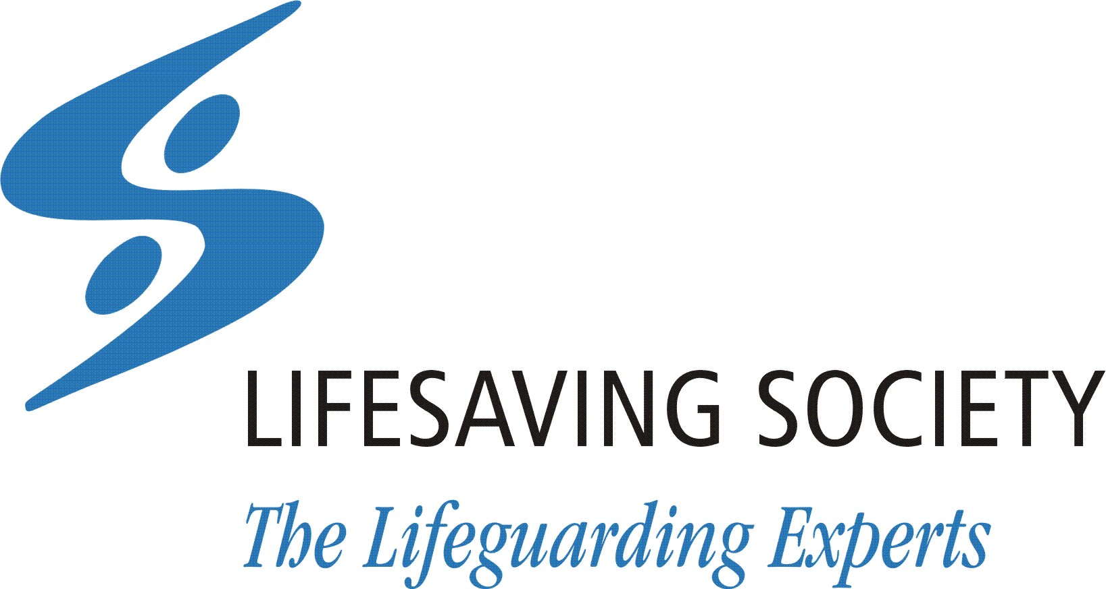

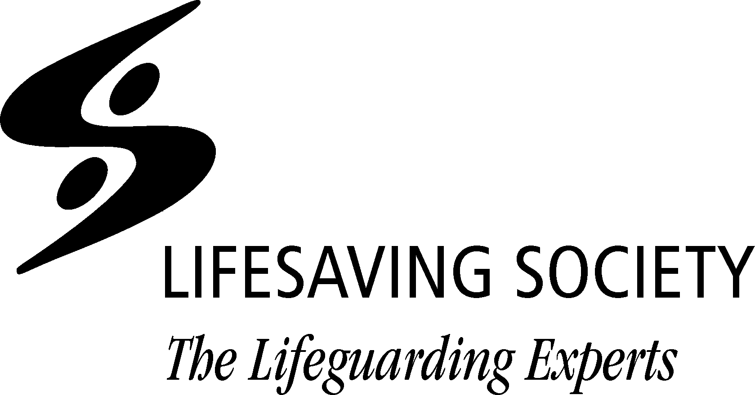LIFESAVING SPORT COMPETITION HANDBOOK

Published by the Lifesaving Society Canada
2420 Bank Street, M012, Ottawa, Ontario K1V 8S1
Telephone: 613-746-5694 Fax: 4613-746-9929
Email: experts@lifesaving.ca Web: www.lifesaving.ca
Second Edition, February 2026
Copyright, February 2026 by the Royal Life Saving Society Canada. The contents of this manual are protected by copyright and may be used only for personal, non-commercial purposes. All other rights are reserved.
Commercial uses including publication, broadcast or redistribution in any medium are prohibited, unless authorized in writing by the publisher. Direct enquiries to the Lifesaving Society Canada.
In any discrepancy between the Official English version of the Lifesaving Sport Competition Handbook and editions in other languages, the most recent English edition is deemed to be the definitive text.
In any discrepancy between the Official English electronic version of the Canadian Lifesaving Sport Competition Rulebook and any print editions, the most recent Official electronic version is deemed to be the definitive text.

® National Lifeguard Service, Water Smart, Swim for Life, Swim to Survive, and Lifesaving Society are registered trademarks of The Royal Life Saving Society Canada. Trademarks other than those owned by the Lifesaving Society used in this document belong to their registered owners.

ACKNOWLEDGEMENTS
We would like to thank the following people for their time and contribution to making this handbook possible; volunteers are integral to the function of this sport, and we are grateful for their expertise and commitment.
The Committee Members:
- Chair: Tara Vanderlinden
- Rebecca Boyd
- Clotilde Anne-Marie Friedmann
- Desiree Janzen
- Lauren Ching
- Oliver Nugent
The National Sport Commission

CONTENTS
- Section 1 General Competition Conditions 6
  - Venue Specific Information as Available 6
  - Equipment 6
  - Scrutineering Of Equipment 7
  - Competition Safety and Security 7
  - Eligibility Rules and Right to Compete 8
  - Entry Procedures 9
  - Uniforms 9
  - Doping Control 10
  - Protests and Appeals 10
  - Seeding 10
  - Awards 11
  - Technical Officials 11
  - Accommodations 11
  - Schedule of Events 11
  - Registration Document or Link for Upload 12

SECTION 1 –LIFESAVING SPORT COMPETITION HANDBOOK
GENERAL COMPETITIVE CONDITIONS

Section 1
GENERAL COMPETITIVE CONDITIONS
The purpose of this handbook is to give guidance and information for specific Canadian Pool Lifesaving Championships (CPLC), Canadian Surf Lifesaving Championships (CSLC), and Canadian Simulated Emergency Response Championships (SERC). This handbook is to be used in conjunction with the Canadian Lifesaving Sport Competition Rulebook and the International Life Saving Federation (ILS) Competition Rule Book.
The Lifesaving Society Canada has the authority to run the national championships for pool, surf/open water, and SERC events. The Lifesaving Society Canada is responsible to record and maintain the national records achieved at these national events or ILS sanctioned international events.
The Lifesaving Society Canada holds the ability to sanction events in pool (long course or short course), SERC, or surf/open water as applicable. Nationally sanctioned pool events are eligible to achieve national records.
1.1 VENUE SPECIFIC INFORMATION
Item | Details
Address
Parking Information
Lock Up Location (if applicable)
Officials Room Location
1.2 EQUIPMENT
Item | Details
Manikin Brand
Rope Brand
Rescue tupe Brand
Obstacle Type
Timing System Brand

1.3 SCRUTINEERING OF EQUIPMENT
Item | Method/Location
Fins
Craft
High Visibility Vest – Only if host not providing
Scrutineering Timing
Visual compliance method
1.4 COMPETITION SAFETY AND SECURITY
Item | Details
Venue Access (times, passes, spectator areas, out of bounds areas, etc.)
Safety Plan link
Contingency Plan link
Warm Up Procedures (times, lanes, equipment, etc.)
Equipment Pool details
High Visibility Vest colour
High Visibility Vest Provided by
High Visibility Vest - requirements (colour, heats, finals, warm ups, etc.)
Craft overnight security (provided/not provided, details)
Branch Concussion Safety and Education Requirements

1.5 ELIGIBILITY RULES AND RIGHT TO COMPETE
- Age of competitor - as per ILS with the exception of Masters.
- The age categories will be Youth, Open and Masters.
  - Youth is defined as 15 - 18 years of age (as of December 31 of the year of the event).
  - Open is 16 years (as of December 31 of the year of the event) and older.
  - Masters is 25 (as of December 31 of the year of the event) and older, the categories are in 5 year increments as per the Canadian Rulebook.
- A government-issued photo identification card is required for the athlete registration process, and to pick up credentials at the beginning of championships.
- Athletes are required to present at marshalling with their competition credentials.
- Canadian Registered Athlete – For enquiry regarding Registered Athlete Status, contact the Lifesaving Society Canada Sport Coordinator.
- The minimum standard is a Lifesaving Society Bronze Star or higher. The award need not be current. Athletes participating in the CPLC, CSLC, SERC are aware of the risk inherent to these events and are assuming all personal risks.
- Athletes are to be in good standing with the Lifesaving Society Canada and their respective provincial/territorial Lifesaving Society Branch(es).
  - Good standing is defined as being current with registration, not having been suspended or disciplined or amid disciplinary proceedings with the Lifesaving Society Canada and/or the provincial/territorial branch(es) the athlete is registered with.
  - Verification of good standing shall be provided by the provincial/territorial branch(es) the athlete is registered with.
- Competitors from other countries may compete in Canadian championships or sanctioned competitions if endorsed (in writing) to do so by their national lifesaving organization. These competitors represent their international club. They may become champions in individual or team events and in the Overall Athlete award, but they are not eligible for Canadian championship club titles. Clubs composed of any non-Canadian members are deemed to be an international club and ineligible for Canadian championship club titles. International Officials may officiate at Canadian championships and sanctioned events if endorsed in writing, by their national lifesaving organization.

1.6 ENTRY PROCEDURES
Item | Details
Registration submission procedures
Registration deadline, including deadline to be a registered national athlete
Cost – General fee per Athlete
Cost – Per individual event
Cost – Per team or relay event
Banquet Costs
Eligibility of athlete – Verification Process
Other
1.7 UNIFORMS
Caps: Reference Canadian Lifesaving Sport Competition Rulebook
Modesty Attire: Reference ILS Competition Rule Book
Taping: Reference ILS Competition Rule Book
Athletes’ Attire - Required minimum attire
Item | Description
Podium Attire – Pool/Beach Side | Athletes are required to wear their team shirt and team shorts or pants to receive any awards earned during the event. Athletes attending without the podium attire will forfeit public receipt of the award.
Podium Attire at Banquet – Award recipients
Banquet – Minimum attire

Officials’ Attire
Item | Description
Shirt - colour, provided/own, etc
Bottoms - colour, etc
Footwear - Type/colour
if applicable
Outerwear - type/colour
if applicable
Hats type/colour if applicable
In water safety vest/ PFD if applicable
1.8 DOPING CONTROL
Item | Description
Doping Control – method
Therapeutic Exemption Form Link | Anti-Doping Policies  https://lifesaving.ca/lifesaving-sport/rules-policies/
1.9 PROTESTS AND APPEALS
The process for protest and appeal is outlined in the current ILS Competition Rule Book. For CPLC, CSLC, and SERC, the cost for an appeal is $100 CAD, in cash (bills).
1.10 SEEDING
In preliminary events
References: ILS Competition Rule Book and Canadian Lifesaving Sport Competition Rulebook
All preliminary events will be seeded according to time, and will include Youth, Open and Masters athletes.
Master events are direct timed finals only.
In final events
References: ILS Competition Rule Book and Canadian Lifesaving Sport Competition Rulebook
- A fine being assigned to the team is $100 CAD cash (bills).
1.11 AWARDS
Reference: Canadian Lifesaving Sport Competition Rulebook
Additional Host Specific Awards (if applicable):
1.12 TECHNICAL OFFICIALS
Officials are to be in good standing with Lifesaving Society Canada and their respective provincial/territorial lifesaving branch.
Item | Description
Application Form link
Included Items (accommodations, meals, banquet, uniform, etc.)
Other
1.13 ACCOMMODATIONS
Group booking for teams or officials
Name of facility(ies) | Booking Reference Number | Distance to Venue
Other (parking, breakfast, etc.)

1.14 SCHEDULE OF EVENTS
Day 1 | Day 2 | Day 3
Preliminaries | Preliminaries | Preliminaries
Finals | Finals | Finals

1.15 REGISTRATION DOCUMENT OR LINK FOR UPLOAD
Please include link to registration form/link to upload registrations.

Contact Us
Alberta and Northwest Territories
13123 – 156 Street NW
Edmonton, Alberta T5V 1V2
Tel: 780.415.1755
Email: experts@lifesaving.org
Website: www.lifesaving.org
British Columbia and Yukon Territory
Unit 112 - 3989 Henning Drive
Burnaby, British Columbia V5C 6N5
Tel: 604.299.5450
Email: info@lifesaving.bc.ca
Website: www.lifesaving.bc.ca
Manitoba
100-383 Provencher Blvd.
Winnipeg, Manitoba R2H OG9
Tel: 204.956.2124
Email: aquatics@lifesaving.mb.ca
Website: www.lifesaving.mb.ca
National Office
2420 Bank Street, M012
Ottawa, Ontario K1V 8S1
Tel: 613.746.5694
Email: experts@lifesaving.ca
Website: www.lifesaving.ca
New Brunswick
70 Melissa Street
Fredericton, New Brunswick E3A 6W1
Tel: 506.455.5762
Email: info@lifesavingnb.ca
Website: www.lifesavingnb.ca
Newfoundland and Labrador
11 Austin Street, PO Box 8065, Station “A”
St. John’s, Newfoundland A1B 3M9
Tel: 709.576.1953
Email: info@lifesavingnfl.ca
Website: www.lifesavingnl.ca
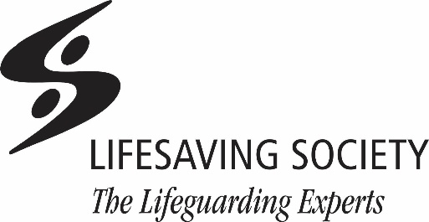

Nova Scotia
5516 Spring Garden Road, 4th Floor
Halifax, Nova Scotia B3J 1G6
Tel: 902.425.5450
Email: experts@lifesavingsociety.ns.ca
Website: www.lifesavingsociety.ns.ca
Ontario
400 Consumers Road
Toronto, Ontario M2J 1P8
Tel: 416.490.8844
Email: experts@lifeguarding.com
Website: www.lifesavingsociety.com
Prince Edward Island
PO Box 2411
Charlottetown, Prince Edward Island C1A 8C1
Tel: 902.368.7757
Email: info@lifesavingsocietypei.ca
Website: www.lifesavingsocietypei.ca
Québec
Maison du loisir et du sport
7665 boul. Lacordaire
Saint-Léonard, Quebec H1S 2A7
Tel: 514.252.3100 or 1.800.265.3093
Email: alerte@sauvetage.qc.ca
Website: www.sauvetage.qc.ca
Saskatchewan
2224 Smith Street
Regina, Saskatchewan S4P 2P4
Tel: 306.780.9255
Email: lifesaving@sasktel.net
Website: www.lifesavingsociety.sk.ca

